**Comcast Telecom Consumer Complaints**

OUTPUT :

1. Import data into Python environment.

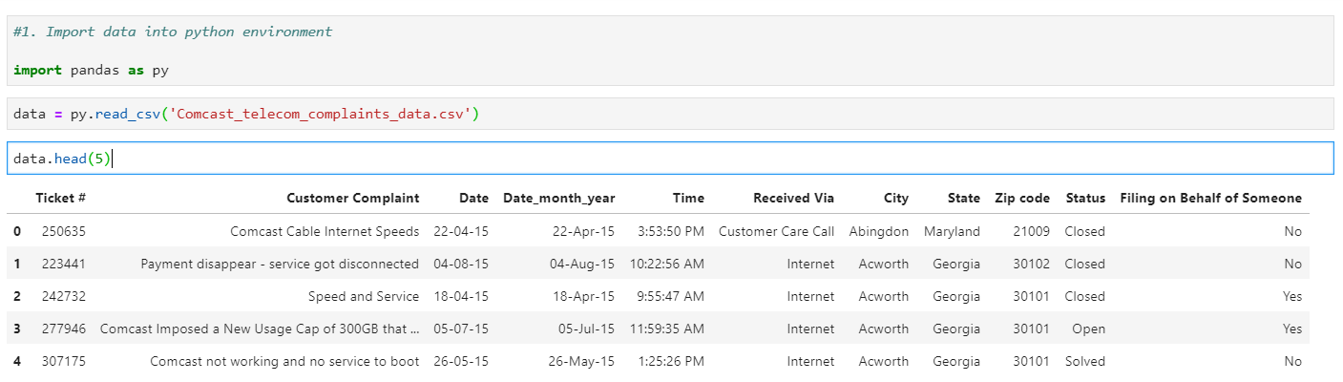

2. Provide the trend chart for the number of complaints at monthly and daily granularity levels.

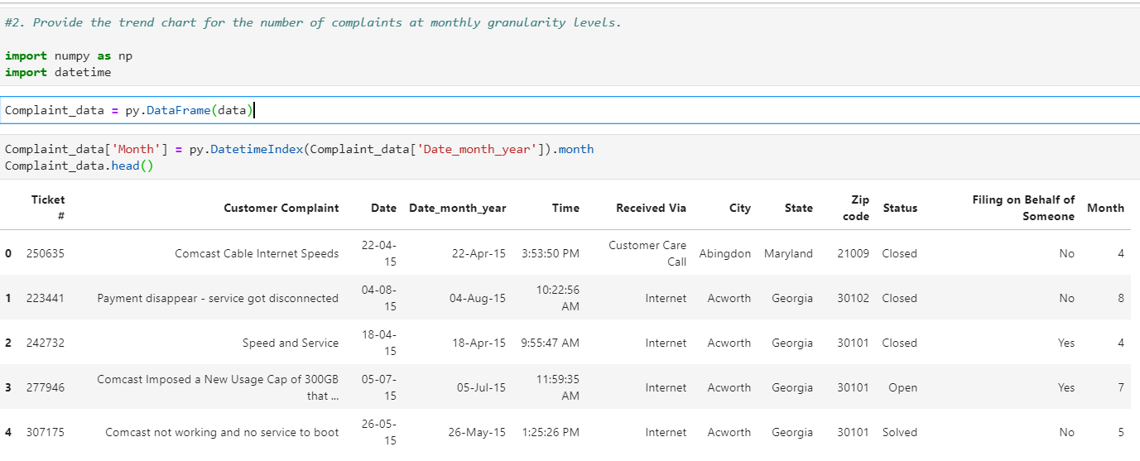

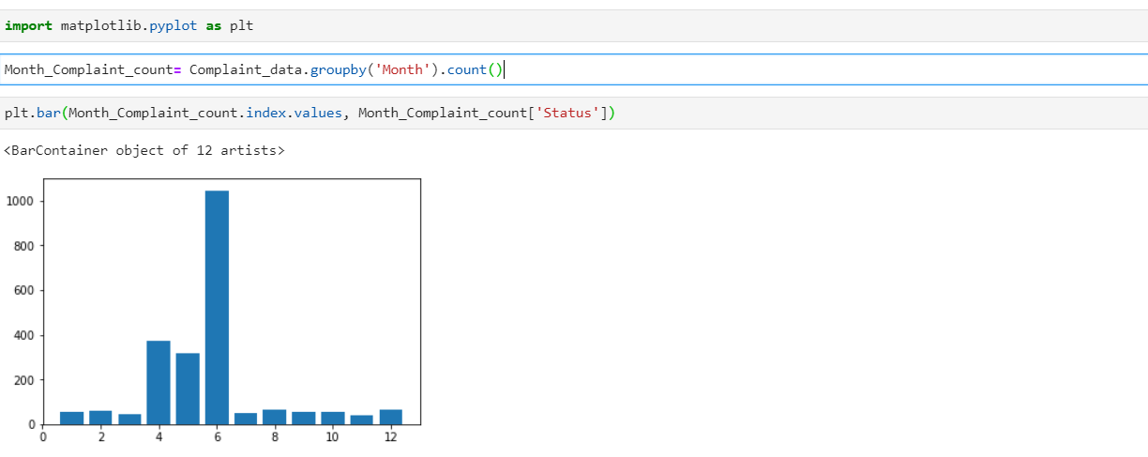

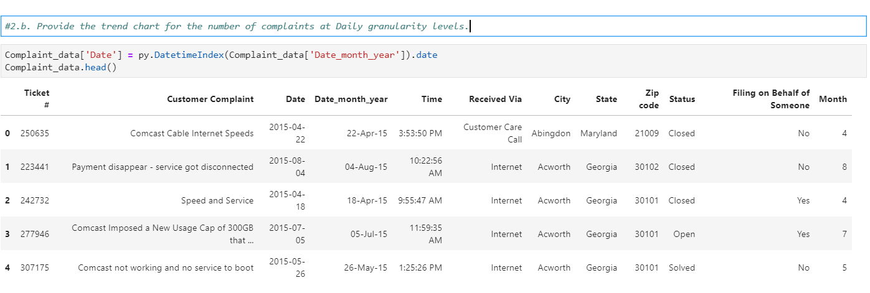

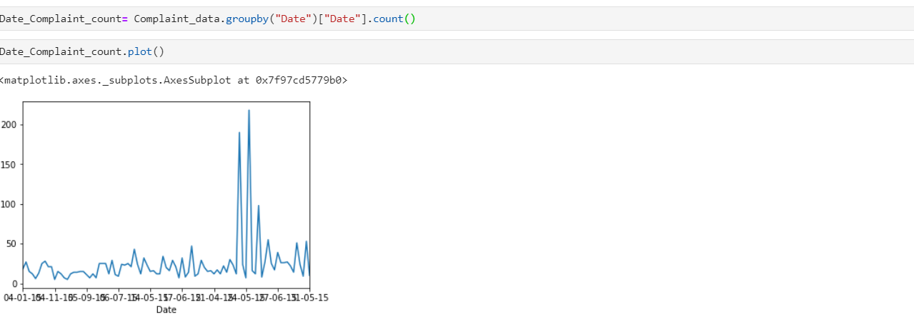

3.  Provide a table with the frequency of complaint types.

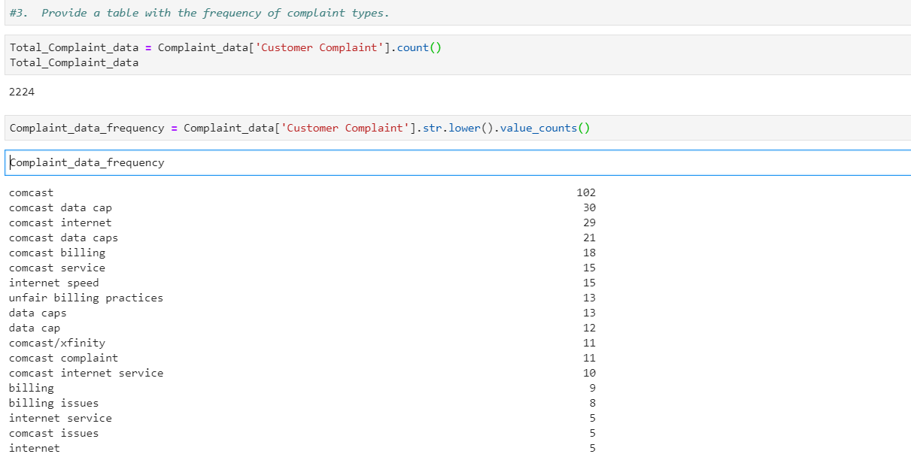

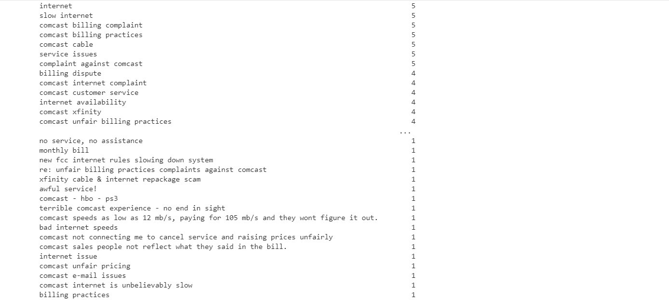

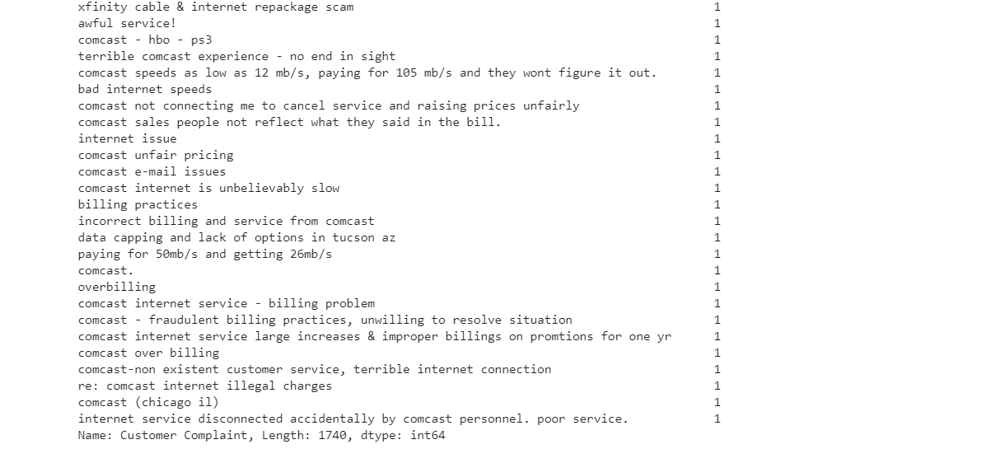

4. Which complaint types are maximum i.e., around internet, network issues, or across any other domains.

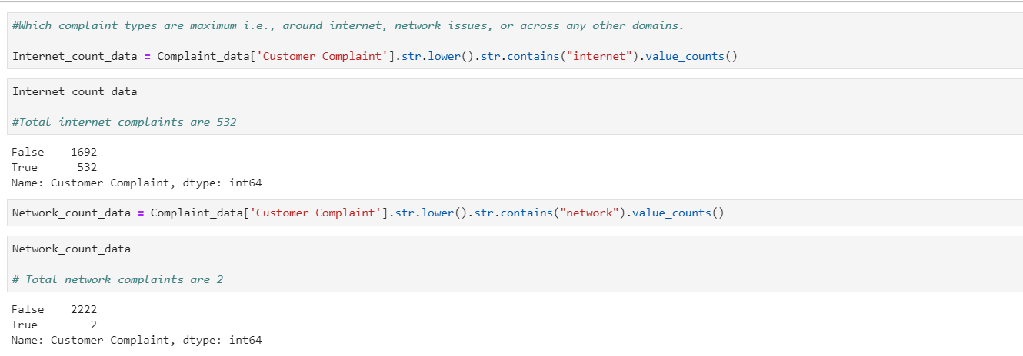

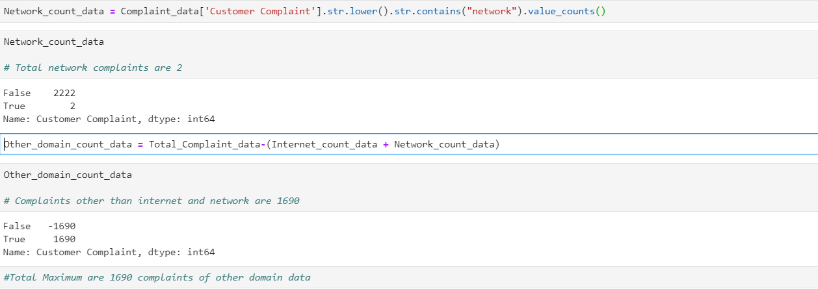

4.Create a new categorical variable with value as **Open**and **Closed**. Open & Pending is to be categorized as Open and Closed & Solved is to be categorized as Closed.

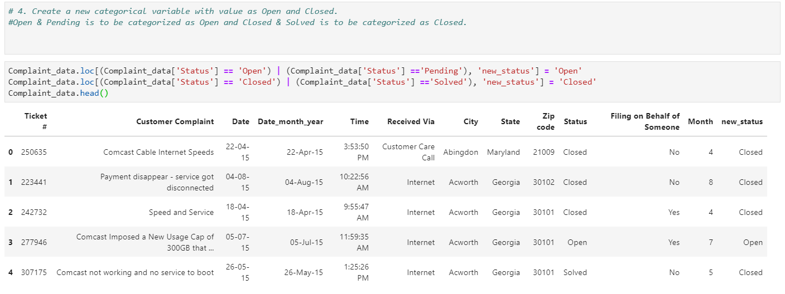

5. Provide state wise status of complaints in a stacked bar chart. 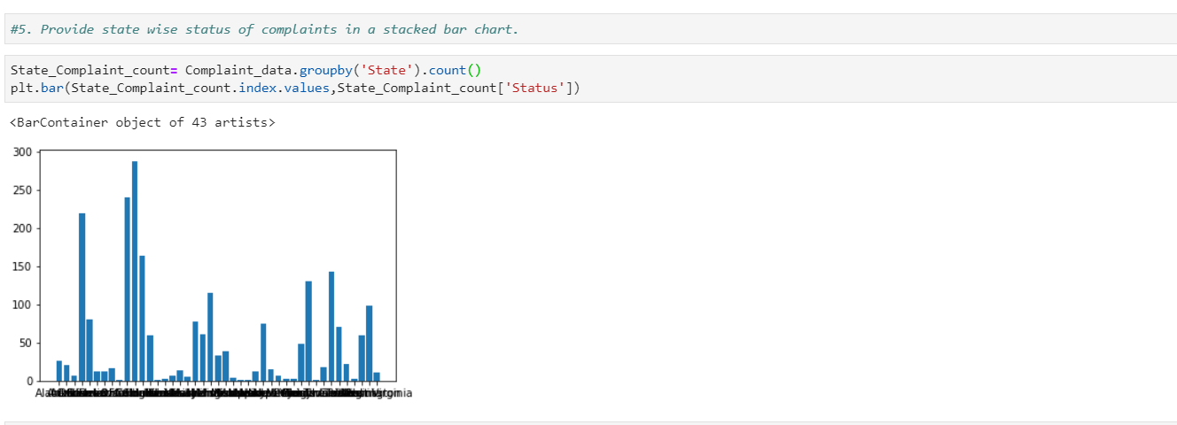

5.Which state has the maximum complaints and Which state has the highest percentage of unresolved complaints

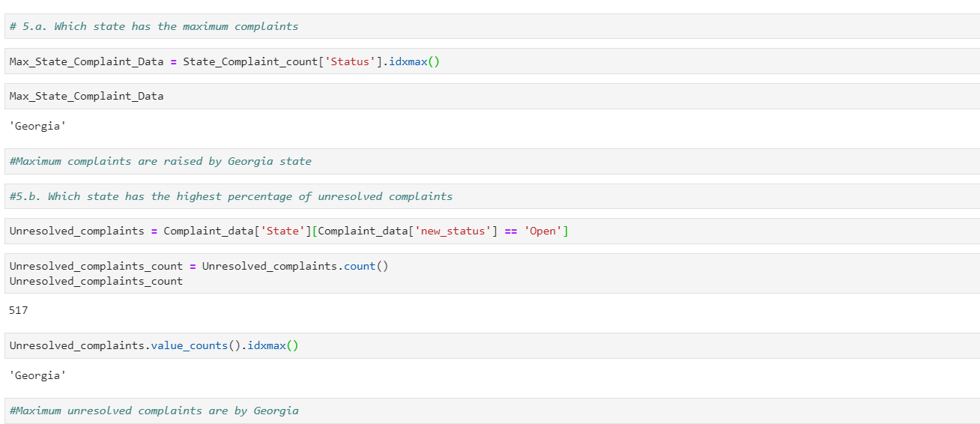

6. Provide the percentage of complaints resolved till date, which were received through the Internet and customer care calls.

